Gilvary grave research st josephs new cemetary

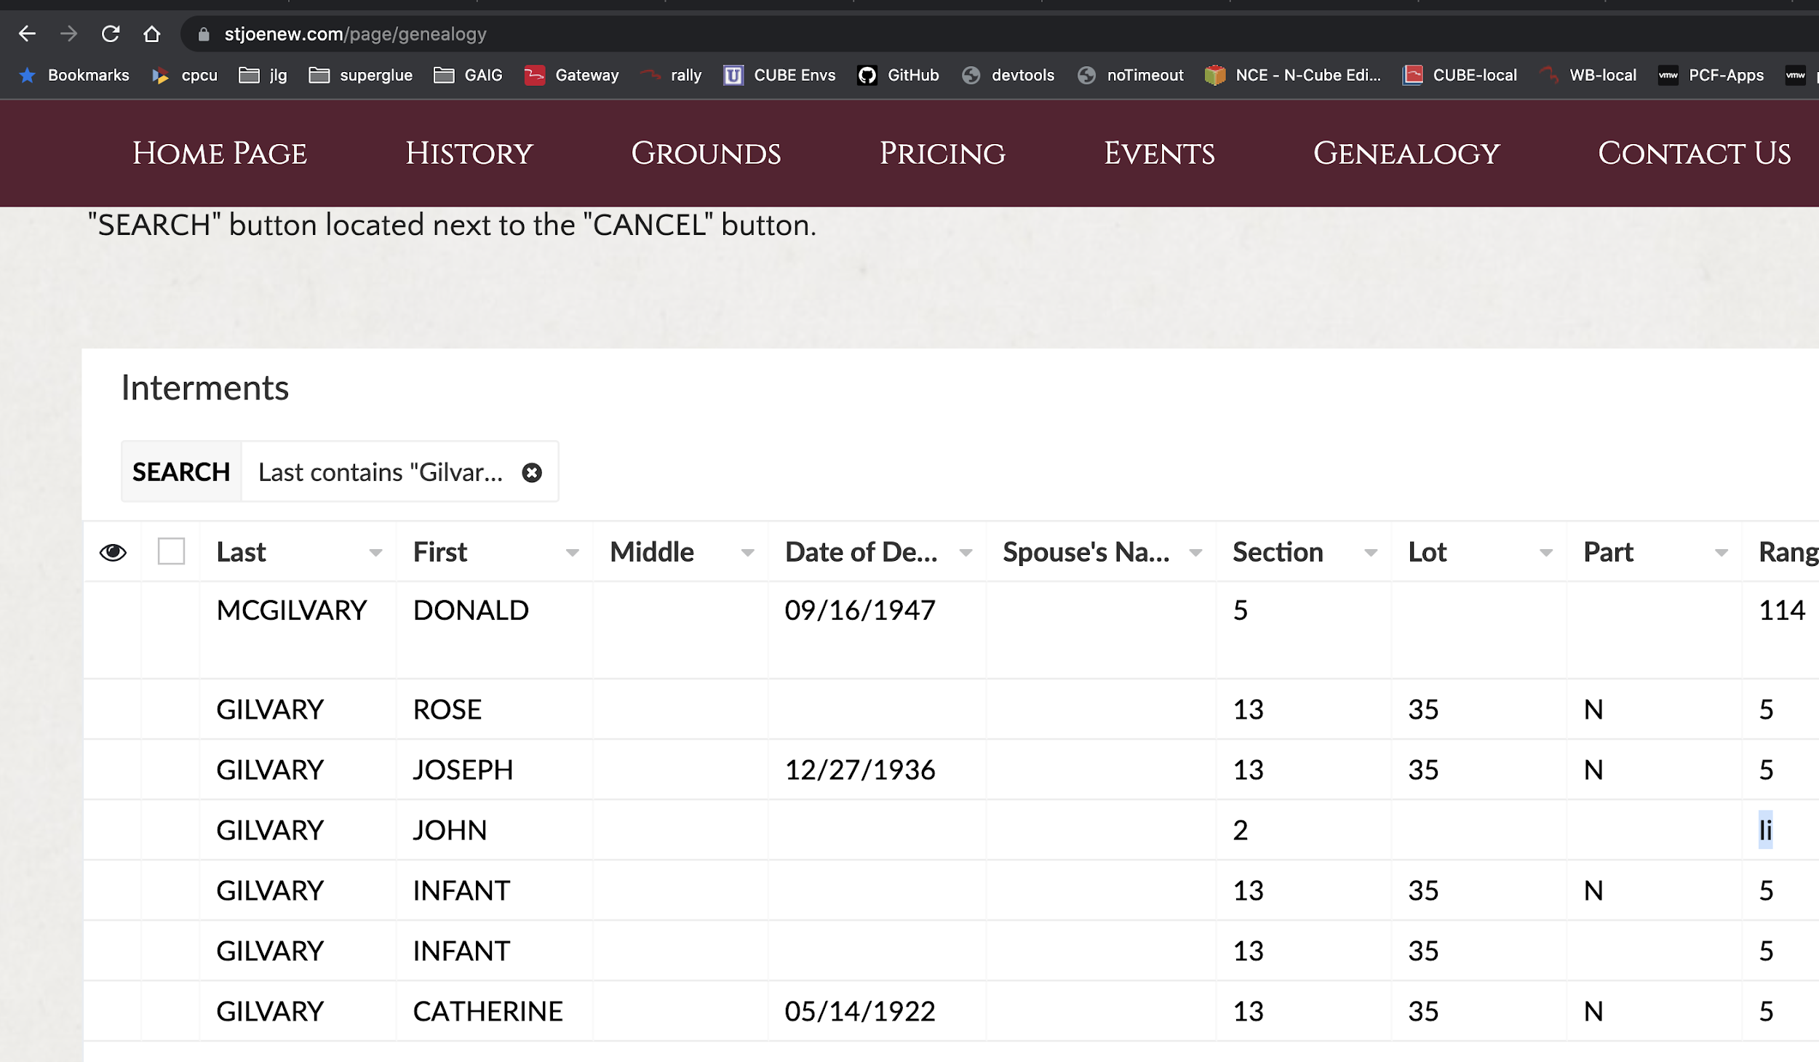

Gilvary Rose record…

07/08/1904

Age

1 MONTH

Parents Name

JAMES & CATHERINE

Infant 1

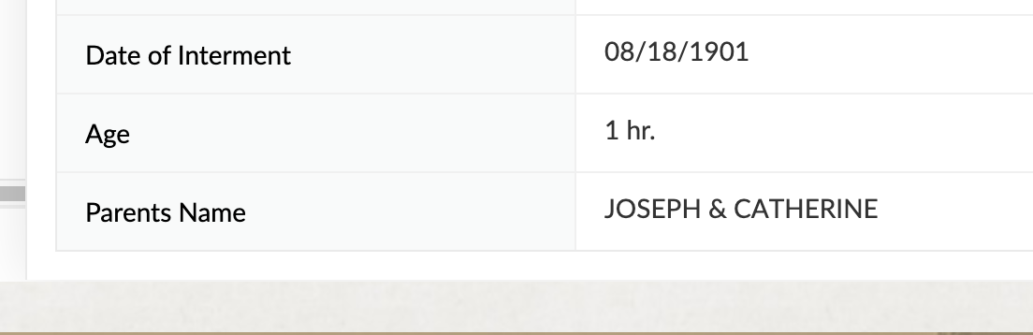

Infant 2

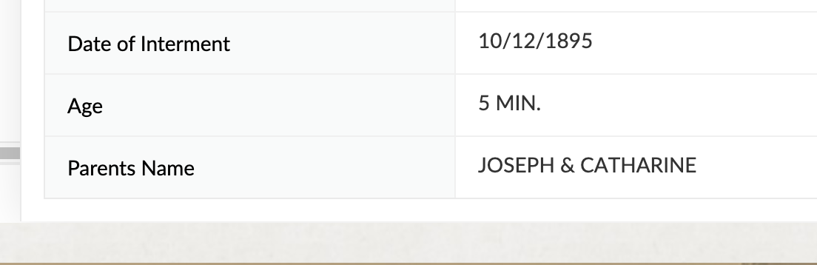

Joseph c. Gilvary

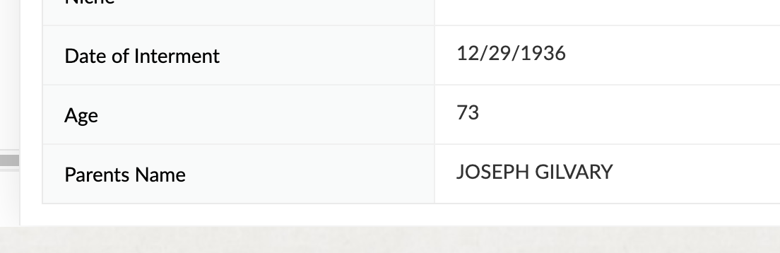

John Gilvary



Catherine Gilvary



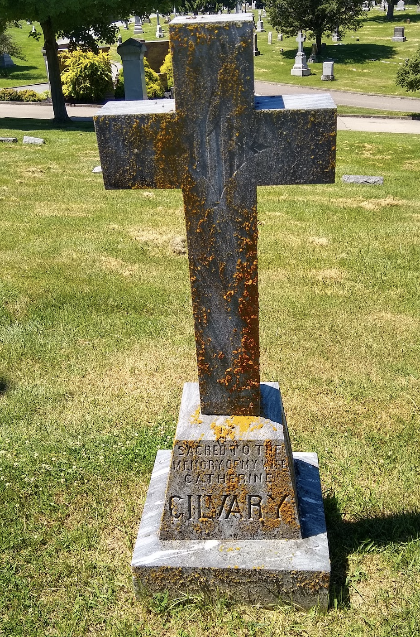Pp0ppppppppppppppppppppppppppppppppp

By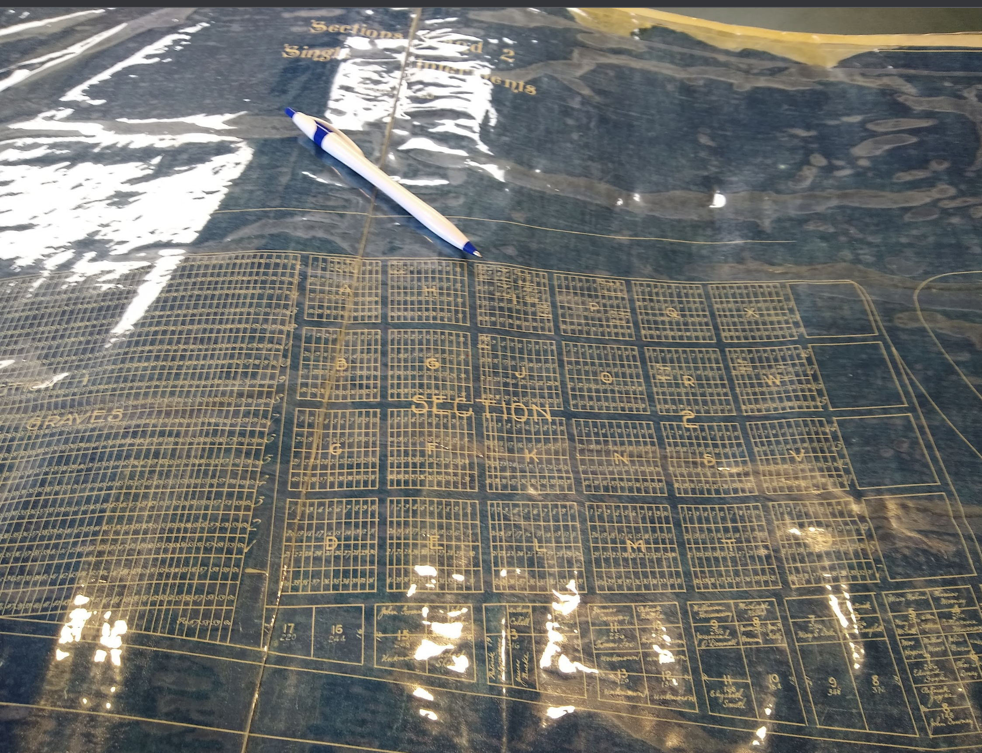

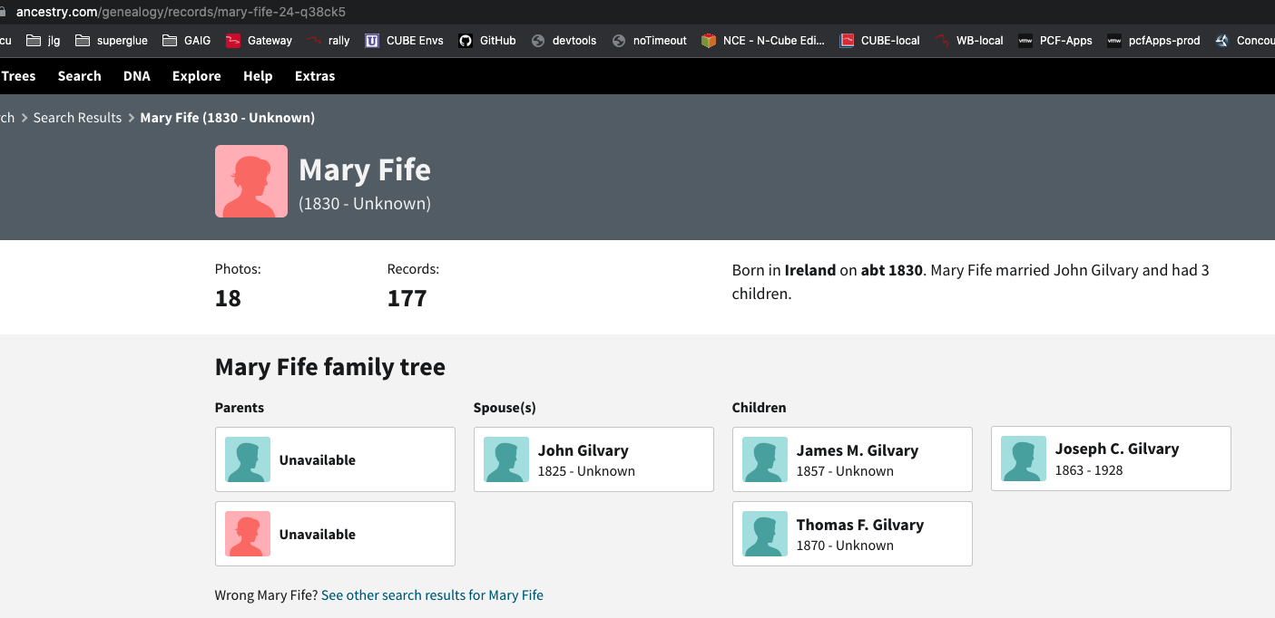

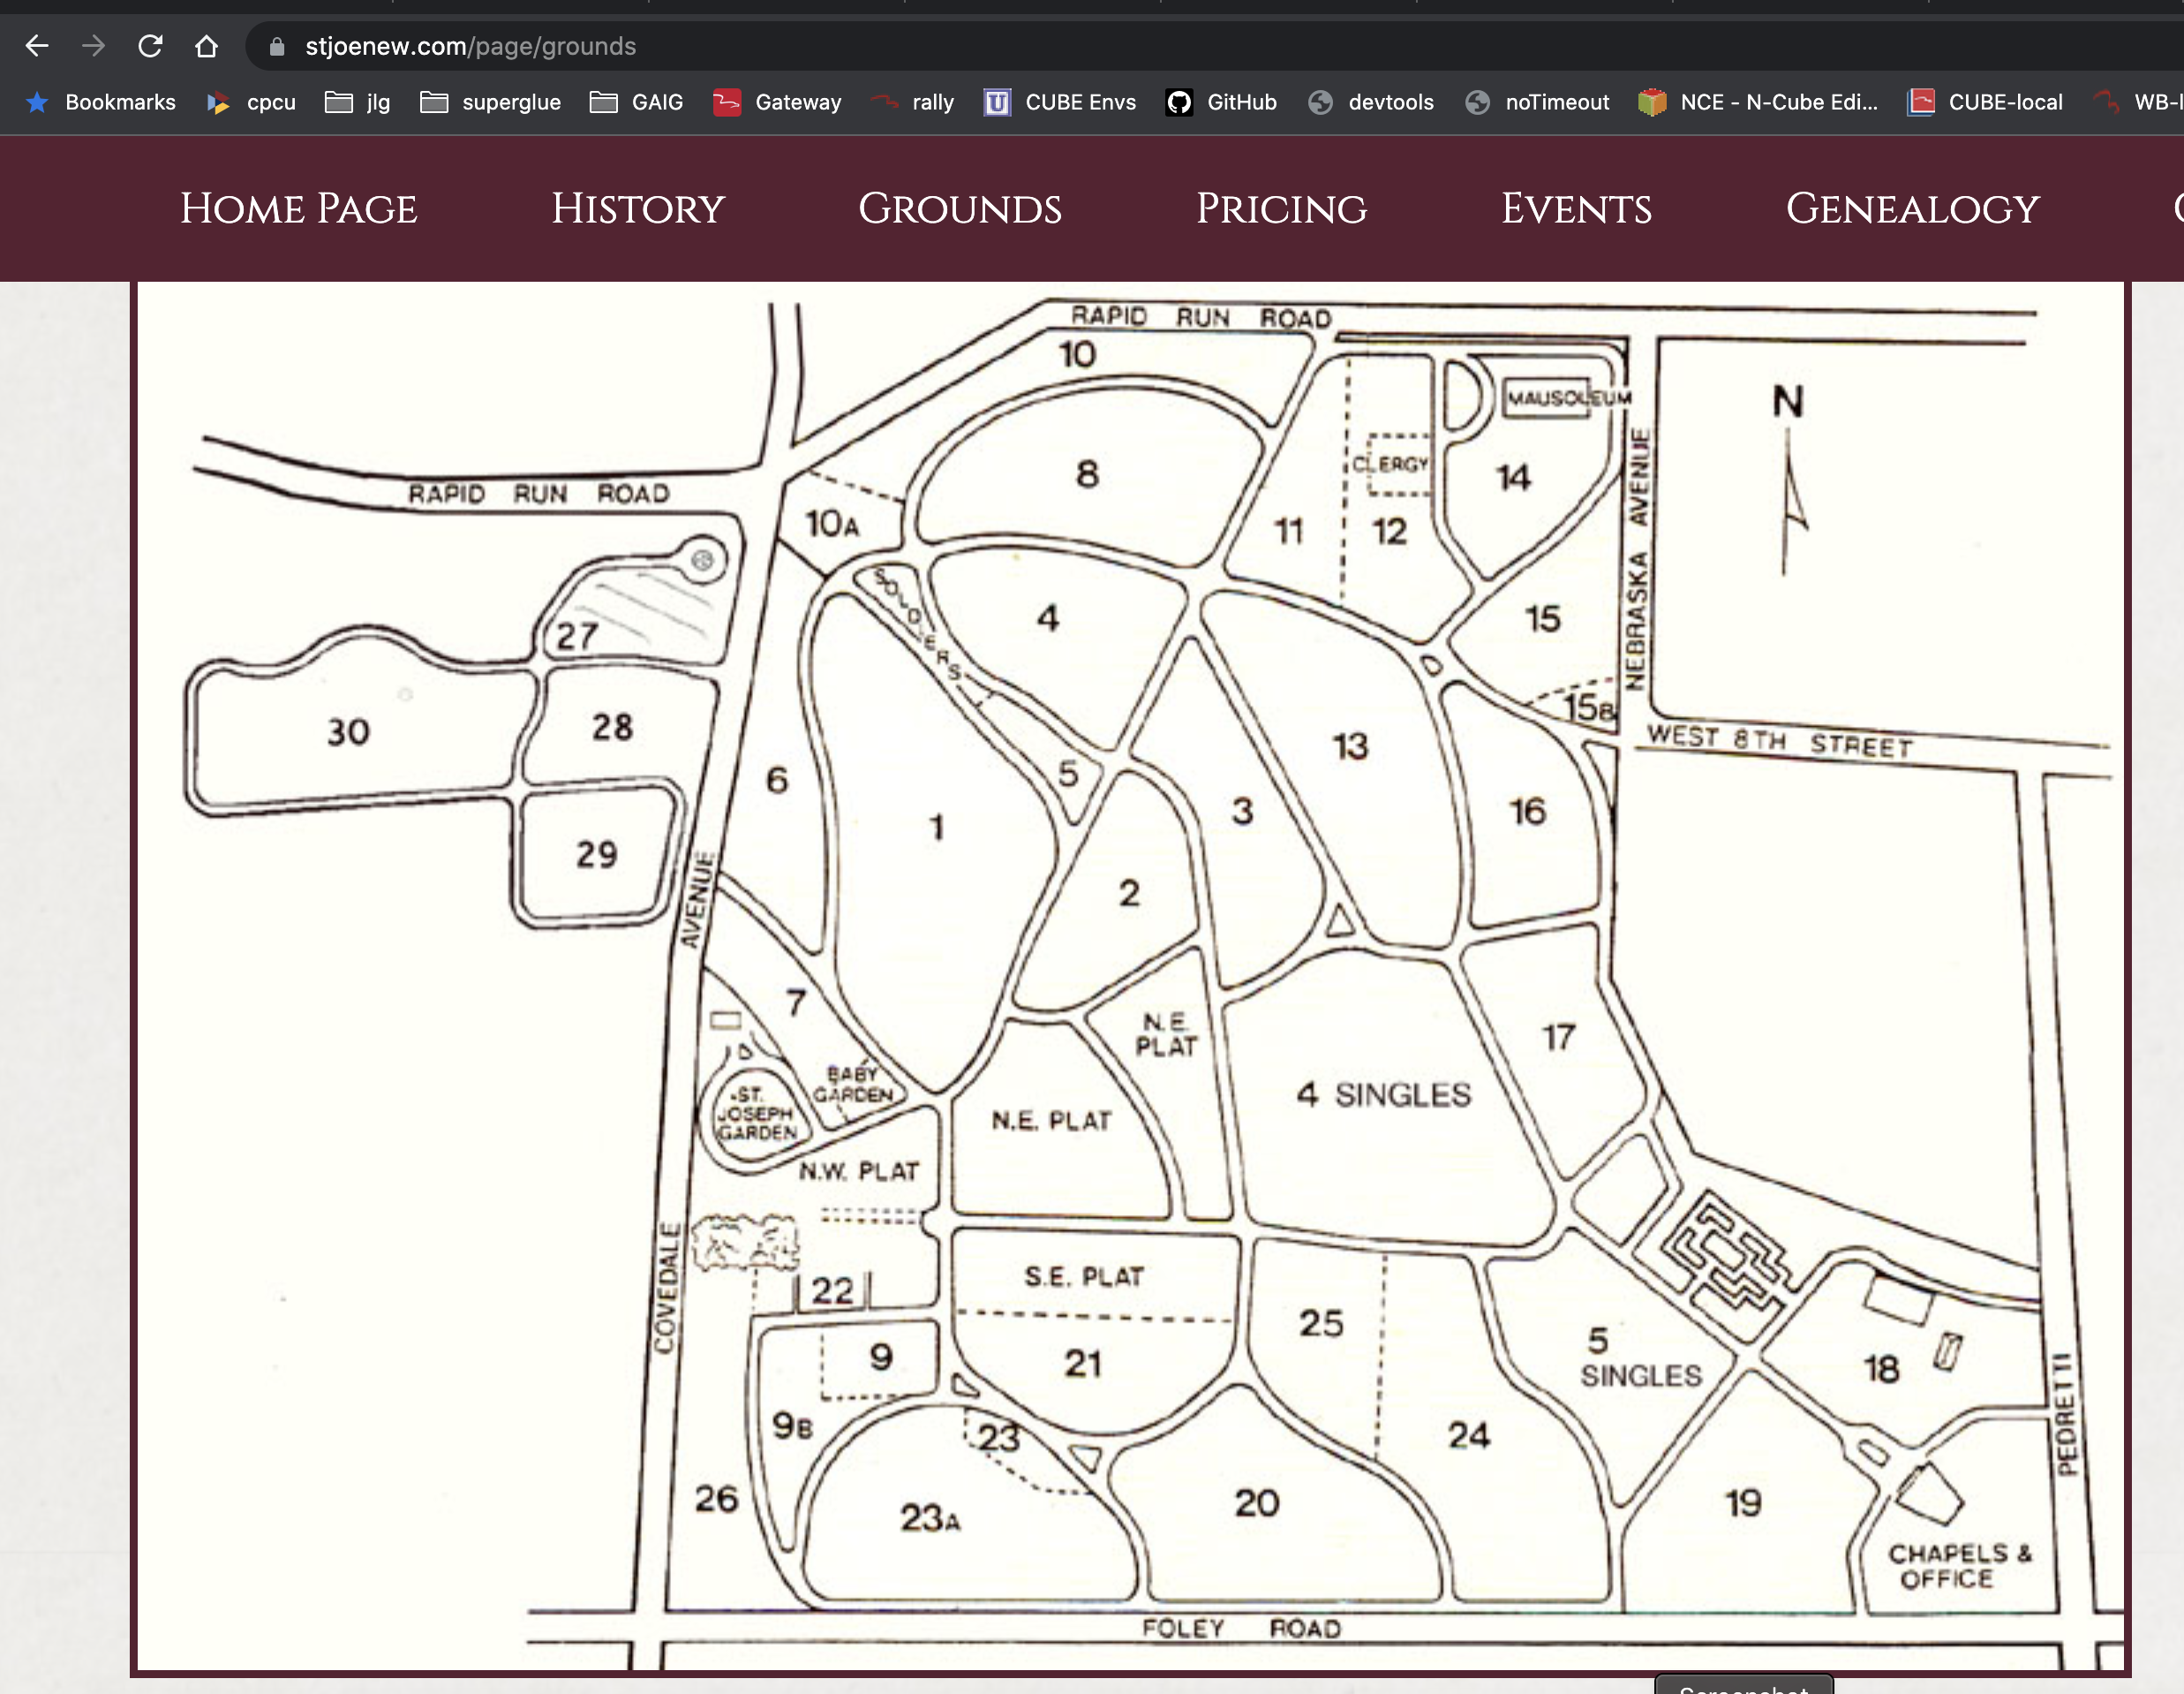

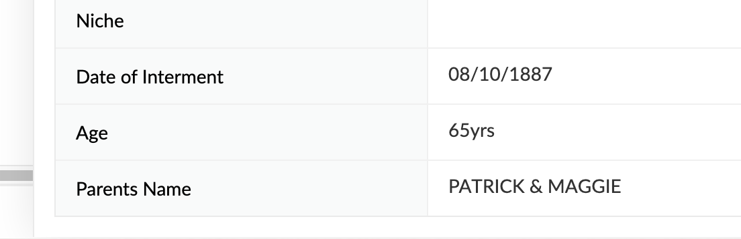

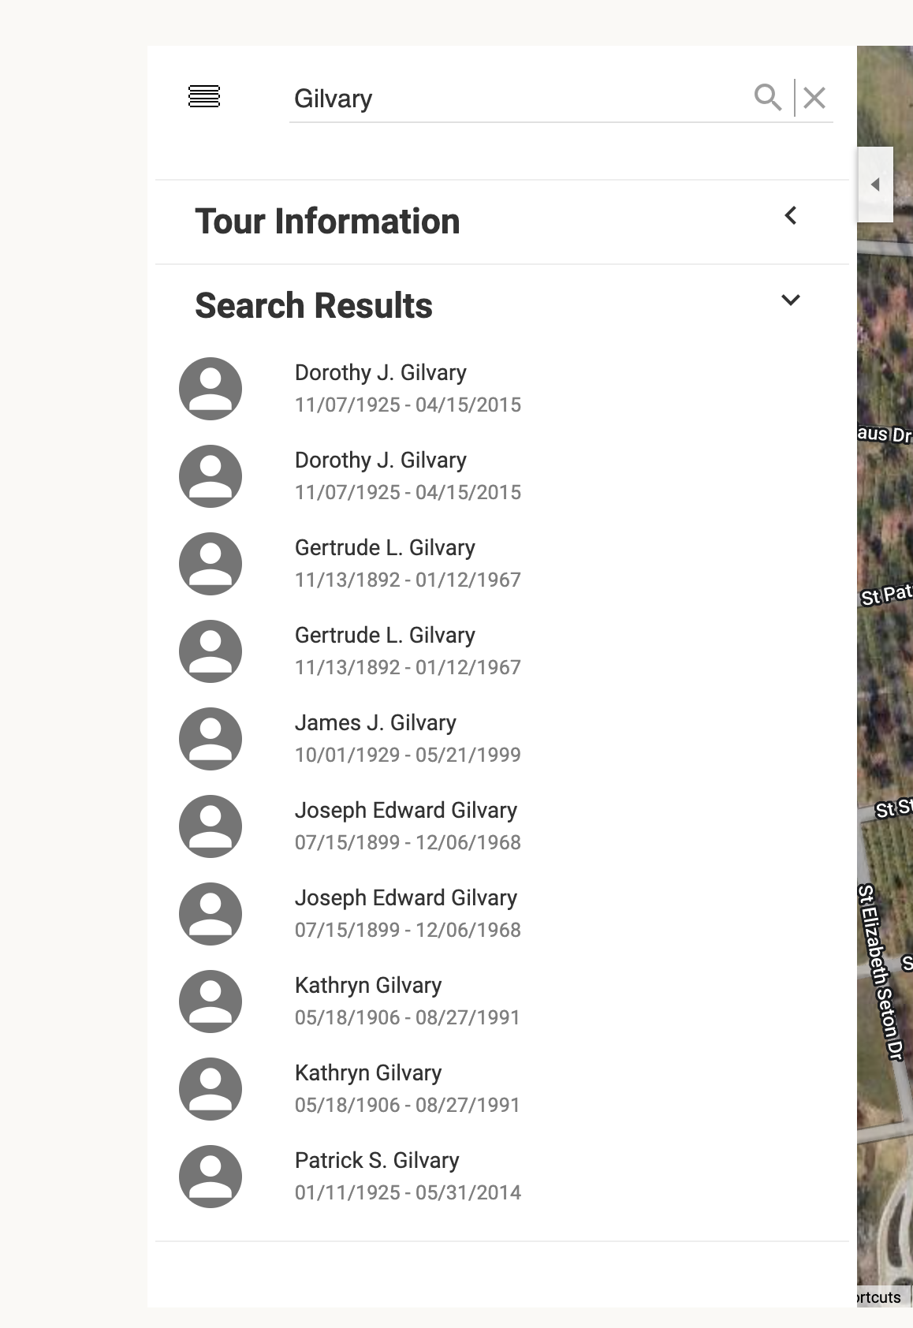

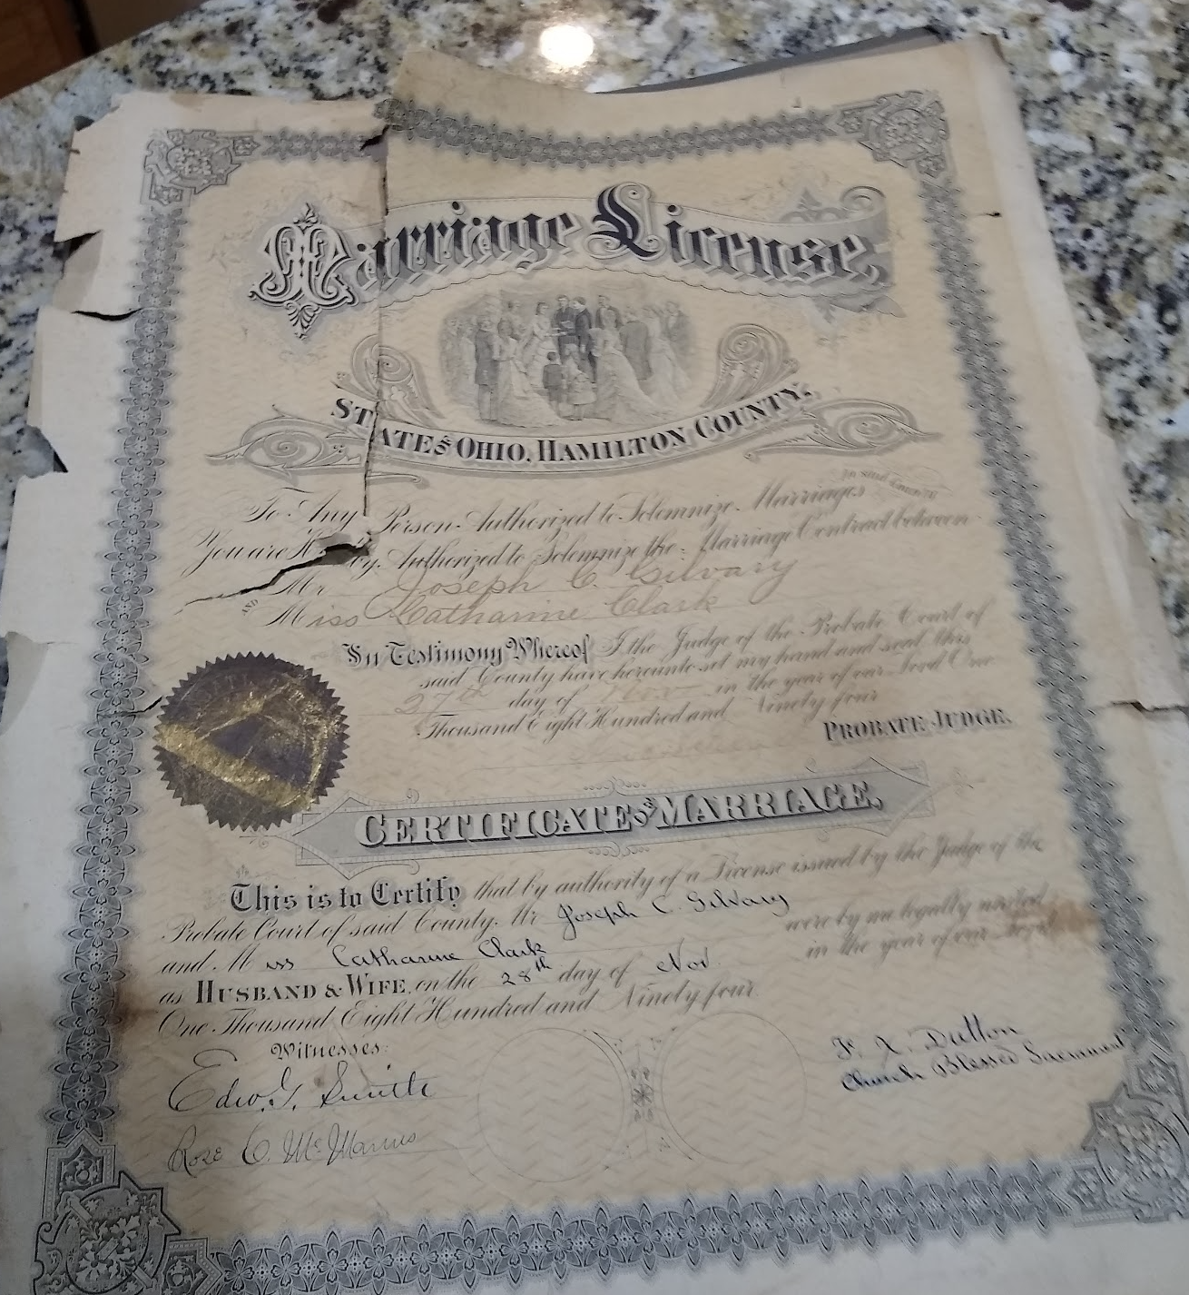

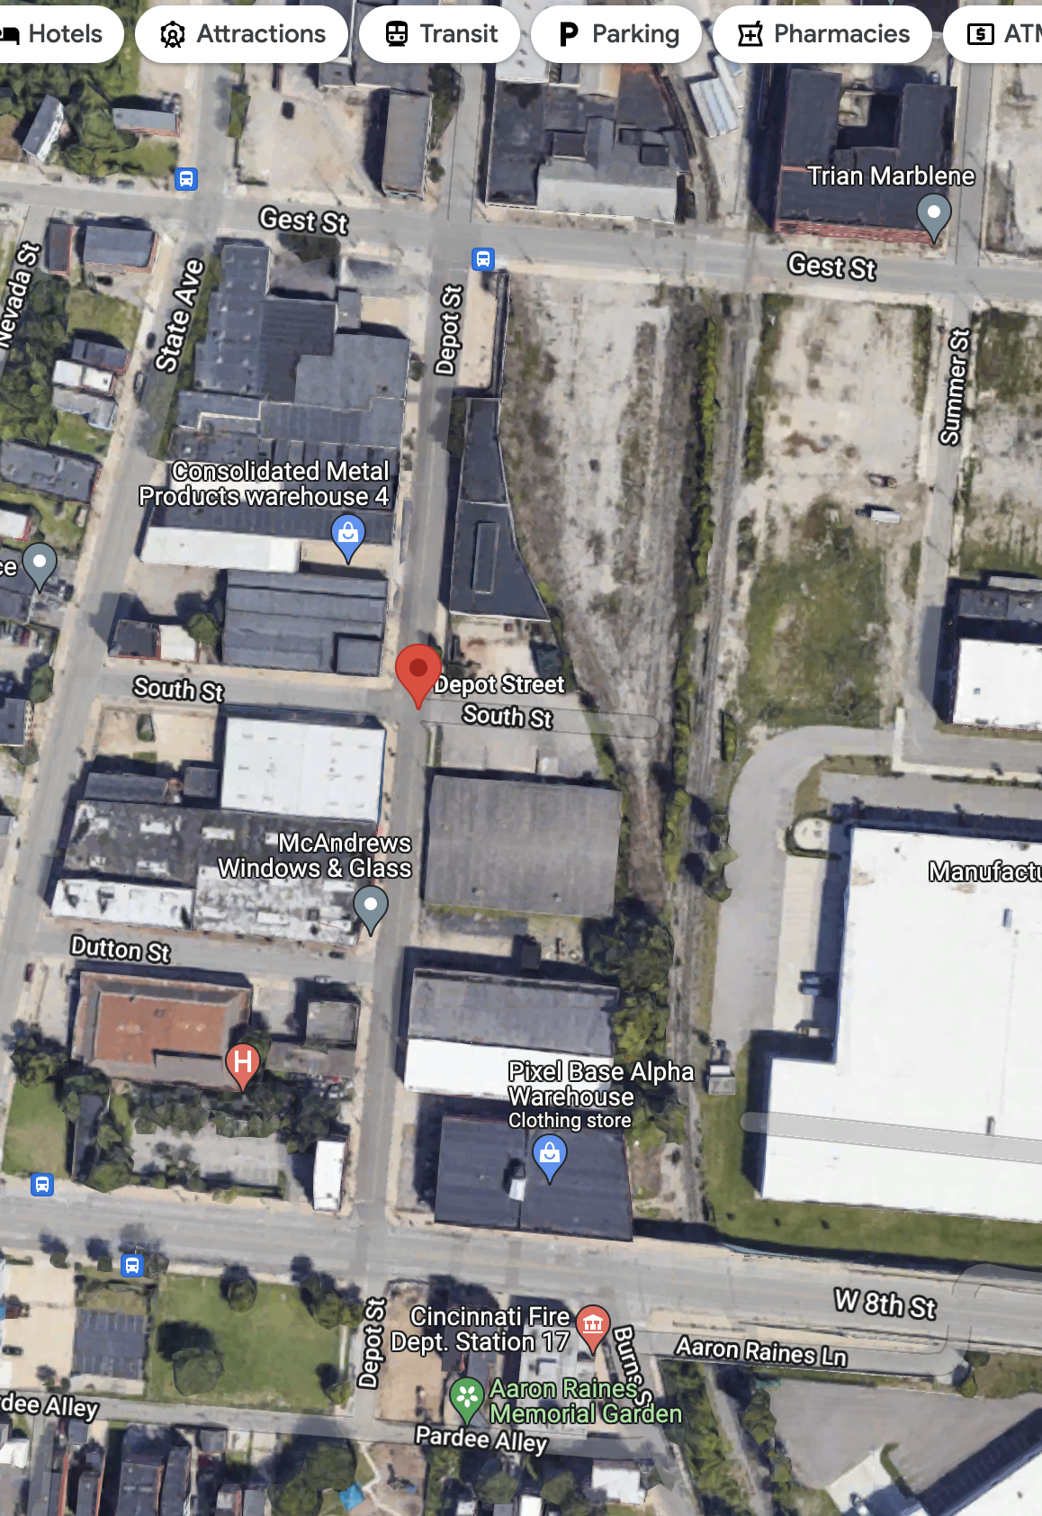

<https://digital.cincinnatilibrary.org/digital/collection/p16998coll5/id/191843/>

1869 Gilvary John peddler h.e.s. oregon nr 3d

1870 Gilvary 0 found

1871 Gilvary 0 found

1872 Gilvary Jas Clk bds e.s Oregon h. 3d and Observatory rd

Gilvary John lab h.e.s. Oregon b. ed and Observatory rd.

1873 Gilvary Jas painter h.e.s. Oregon b. Observatory Road and 3d

Gilvary Johnlab h.e.s. Oregon b. Obervaotry Road and 3d

1874 Gilvary Jas m. shade mkr bds e.s. Orgeon nr 3d

Gilvary John r. matters amker bds. e.s. Oregon nr 3d

1875 Gilvary - 0 found

1876 Gilvary - 0 found

1877 Gilvary John mattress maker wks. 144 Main

1878 Gilvary James fireman Gibson house

Gilvary John lab h. 24 Oregon

1879 Gilvary Jas M. porter h. 24 Oregon

Gilvary John LAB 24 Oregon

1880 Gilvary - 0 found

1881 Gilvary, John lab, H. 1010 Oregon

1882 Gilvary, Jas porter 105 oregon

Gilvary, John lab h 105 Oregon

Gilvary, Jos. fireman Gibson House

Gilvary, Jos shoe finisher h. 105 Oregon

1883 Gilvary, jas houseman, gibson house

Gilvary , Jas M. porter 106 Oregon

Gilvary, John h. 105Oregon

Gilvary Jos c shoemaker 105 Oregon

1884 Gilvary, Jas M. window shade painter h 105 Oregon

Gilvary, John h. 105 Oregon

Gilvary, Jas C. porter h. 105 Oregon

1885 Gilvary, Jas painterbds 195 Broadway

Gilvary John res. Home for the aged poor

Gilvary Jos porterbds 195 Boradway

Gilvary Thos. dash mkr bds 195 Broadway

1886 Gilvary John Home for the aged poor

Gilvary Jos C. porter bds s.w. 6th and Broadway

Gilvary Thos. F. porter, h. s.w.c 6th and Broadway

1887 Gilvary 0 found

1888 Gilvary 0 found

1889 Gilvary 0 found

1890 Gilvary, Jos C. porter h 8 Harrison

1891 Gilvary, Jos C. porter, rooms 8 Harrison

1892 Gilvary 0 found

1893 Gilvary, Jos. C. rooms 249 vine

1894 Gilvary, Jos. C. rooms 294 vine

1895 1900 none

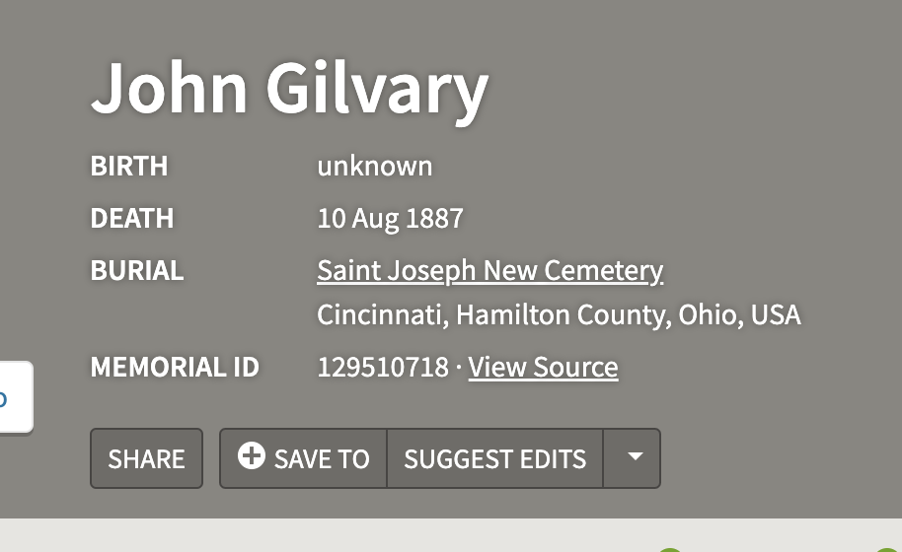



<https://www.jstor.org/stable/community.32159889?seq=1>

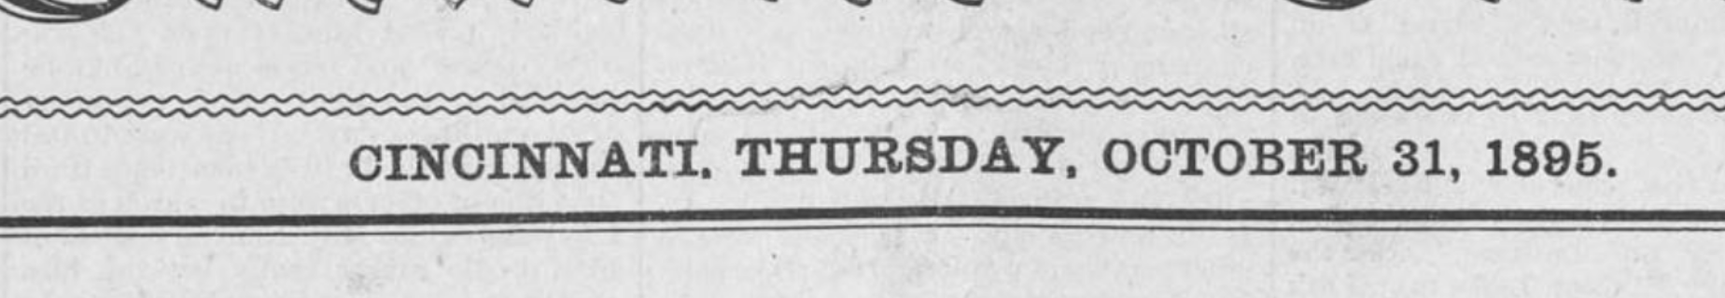

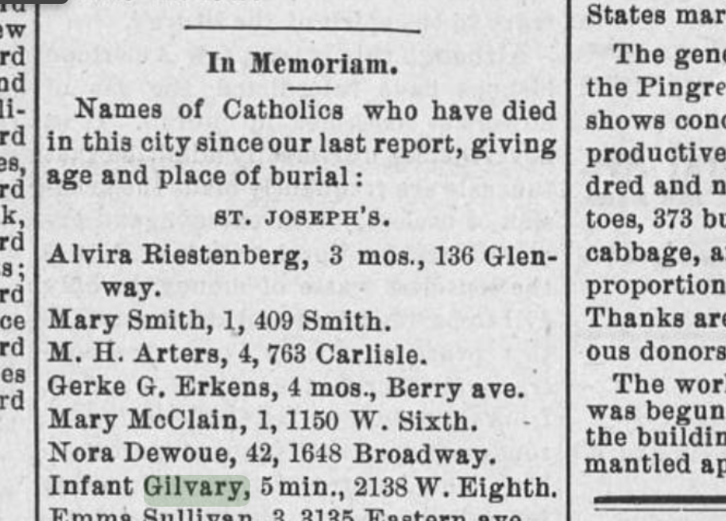

The Catholic Telegraph, Volume LXXVIII, Number 10, 11 March 1909

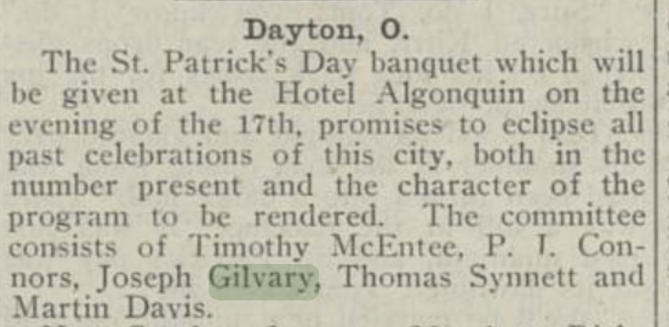

The Catholic Telegraph, Volume LXXXII, Number 3, 16 January 1913

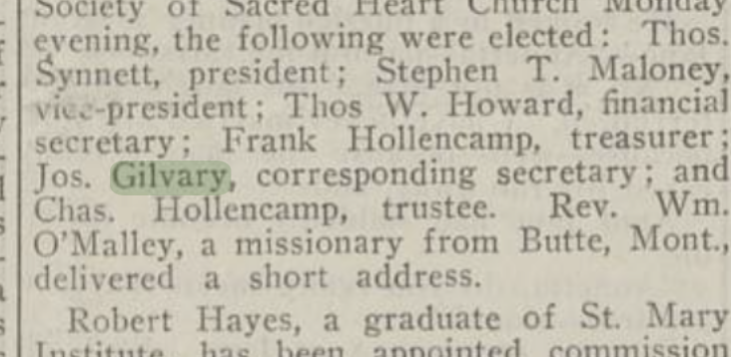

<https://www.myheritage.com/tree-wizard/1376054882/discovery-individuals/1>

